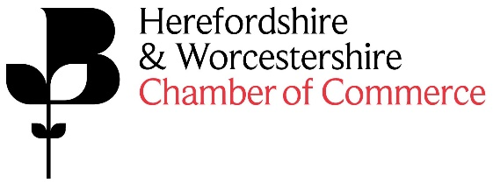

The Food and Drink Conference is now in it’s third year, after delivering two successful half day events which attracted over 50 food and drink businesses in its first year and 65 in its second year, feedback from attendees suggested this be made into an annual event. The event provides attendees with great networking opportunities, practical advice and the chance to hear from some inspirational businesses and industry specialists. (mfg Solicitors are already one of the confirmed sponsors for this event, we are looking for one more sponsor).
As the sponsor of this event you will receive:
- Co-Branded publicising of the event - Food and Drink Conference sponsored by mfg Solicitors and XXX
- Company logo and link to the company’s website to be on the Chamber website event page
- Company logo and link to the company’s website on all E-Newsletters promoting the event – circa 6,000 subscribers
- Company logo in Business Direction promoting the event – 4,000 copies
- Company logo on event flyer
- Co-Branding at the event itself including: table literature, display of pop ups, company logo on screen on the presentation
- Opportunity to deliver 5-minute welcome speech/presentation to attendees
- Access to a minimum of 50 attendees at the event

Cost of sponsorship:
£1,500.00+VAT~
Feedback from the 2019 Conference:

By far one of the best events I've been to in the last year. Informative, insightful and engaging! I would highly recommend to anybody who receives an invite to the next event.
- Inspiring speakers, so important to take the time out of the day to day humdrum to listen to what is going on in the bigger world and to broaden ones knowledge.

The food and drink conference was informative and a good opportunity for industry networking.
- The conference was a useful networking opportunity.

