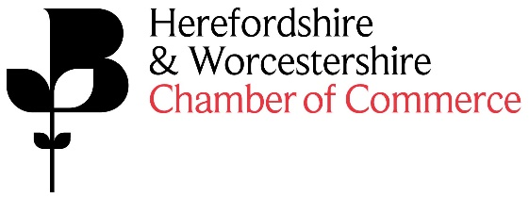

The Economic Conference will give attendees an exclusive first look of the Chambers Business Manifesto, which outlines the key areas the Chamber will be focussing its policy and efforts to support businesses throughout the year. The event will also include informative presentations from different business experts who will provide an update on the local and national business environment for the coming year.
As Event Sponsor you will receive the following benefits:
- Co-Branded publicising of the event – Economic Conference sponsored by XXX
- Company logo and link to the company’s website to be on the Chamber website event page
- Company logo and link to the company’s website on all E-Newsletters promoting the event

- Company logo in Business Direction promoting the event – 4,000 copies
- Frequent mentions on Twitter and LinkedIn as the event partner
- Opportunity to deliver 5-minute welcome speech/presentation to attendees
- Opportunity to suggest one of the keynote speakers to address attendees
- Access to a minimum of 50 attendees at the event

- The Chamber will be responsible for all organisation of the event

Cost of sponsorship:
£1,500.00+VAT

