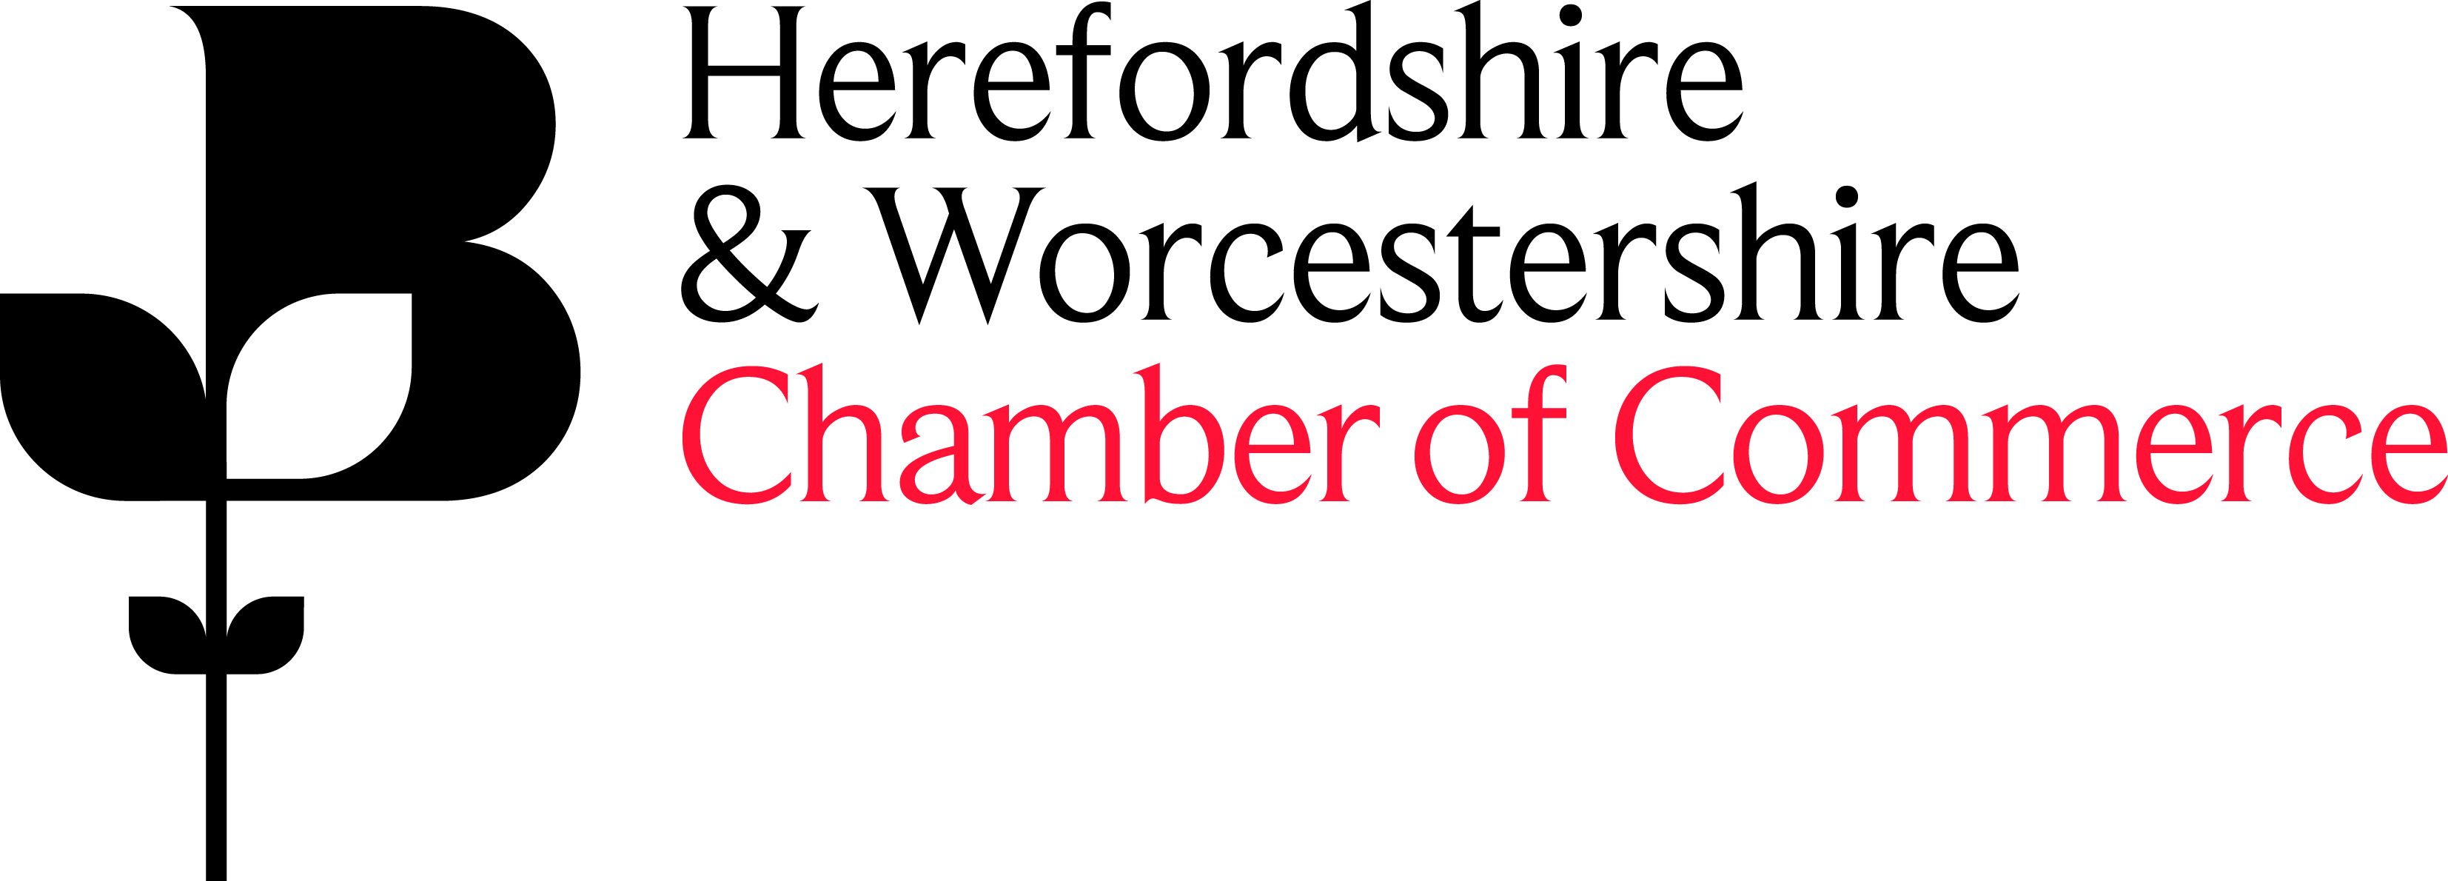

Herefordshire & Worcestershire Chamber of Commerce Quality Policy

Scope: The provision of a comprehensive range of Chamber of Commerce related support services that serves the needs of businesses and individuals within Herefordshire and Worcestershire.

Our Commitment is to:

- Strive for continual improvement of our quality system by:
    - Setting and reviewing annual quality objectives as part of the Business Plan
    - Discussing quality issues, where appropriate, through all communication channels
    - All staff taking ownership of the improvement process, including top management demonstrating leadership and commitment in respect to the quality management system
    - Having a trained, dedicated team of Internal Auditors
    - Having extensive procedures and processes to define how services are provided
    - Measuring and monitoring customer satisfaction, including meeting current and future needs of customers
    - Maintaining a high quality of service for all our customers but if things do go wrong, we have an official complaints procedure to ensure customers are
treated fairly and openly and in a timely fashion to ensure that a resolution is achieved.

- Fulfil the standards required for BS EN ISO 9001:2015, Investors in People, British Chambers of Commerce accreditation and Department for International Trade.

- Respond to all enquiries received via email, verbally or letter, through our relevant dedicated teams/departments, within 3 working days. If required referring and working with our wide range of business contacts, partners and stakeholders to ensure the community has the necessary support and to help business grow.

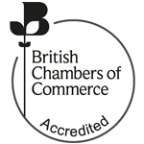
- Develop our internal and external systems using proven technologies to assist in our vision of providing exemplar customer service standards, including complying with legal and regulatory requirements.
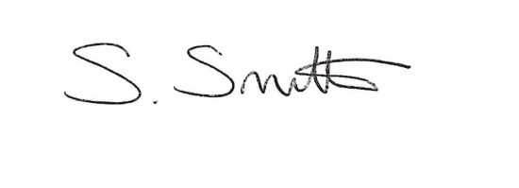
Sharon Smith, Chief Executive

This Quality Policy is reviewed annually as part of the Quality Management Internal Audit Schedule

