West Midlands Virtual Business Expo
Headline Sponsor for Herefordshire & Worcestershire - Hewett Recruitment
Monday 22nd March – Friday 26th March 2021.
Booking information:
Name of Company:
Company Address:
Company Telephone:
Company Twitter:
Company LinkedIn:
Company Website:
Booking Contact Name & Job Title:
(This is the person who will receive all expo communication)
Contact Email Address:
Nature of Business:

Stand options:
There are two options of stands which have different features.
Stand Feature | Standard | Deluxe
Initial stand build and design | Yes | Yes
Introductory one-line description of your business | Yes | Yes
Summary of your business, website link, telephone number and email address | Yes | Yes
Business Audio message (MP3 file) | Yes | Yes
Meet your Team Profiles and photos | Yes – 1 photo | Yes – 3 photos
Brochure stand picture | Yes – 1 brochure with default image | Yes – 1 brochure with logo-based image
Business card enquiry form |  | Yes – Designated form to capture visitor data
Promotional video display |  | Yes – 1 promotional video link
Zoom Rooms for individual discussions |  | Yes – up to 3
Links to your social media platforms |  | Yes

Stand Option | Cost for Members | Cost for Non-Members | Selection (please tick)
Standard Exhibition Stand | £99.00+VAT | £149.00+VAT
Deluxe Exhibition Stand | £179.00+VAT | £269.00+VAT
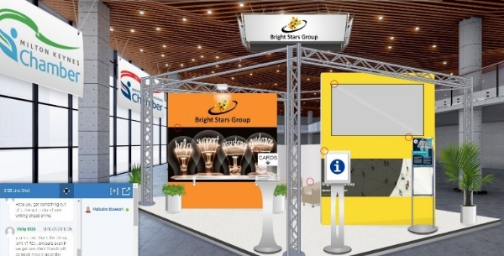
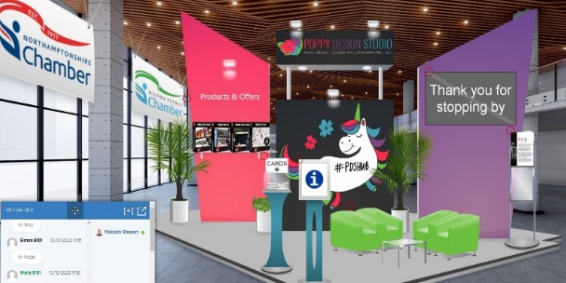
*Images are an example only and not an exact representation of every stand.*

Payment Options:
Payment for the Exhibition must made once this form is returned to events@hwchamber.co.uk for processing. Our partner for this exhibition cannot start the build of your stand until payment is made.

- Payment by Credit or Debit Card Please call the Finance Team on 01905 673600 to make payment by credit or debit card.
- Payment by Automated Bank Payment Please call the Finance Team on 01905 673600 to be given an order number to quote with the payment. Herefordshire and Worcestershire Chamber of Commerce Bank Details: Sort code: 40-47-17 Account number: 12544415.
- Payment by Cheque Please make your cheque payable to ‘Herefordshire & Worcestershire Chamber of Commerce’

Cancellations:
Please note that cancellation requests must be received in writing by Friday 25th February 2021 in order to be eligible for a refund.

Data Protection Notice:
Herefordshire and Worcestershire Chamber of Commerce [the Chamber] is registered under the Data Protection Act 1998 and takes the processing of your personal data very seriously. Please take your time to read this notice so that you are fully aware of what you are consenting to. Please contact us if you are unsure about any part of this notice by telephone 01905 673600 or e-mail enquiries@hwchamber.co.uk. The Chamber’s Data Protection Officer can be contacted at the registered address stated on this form. The Chamber’s privacy policy can be viewed on the Chamber website at www.hwchamber.co.uk.

Declaration:
I, the undersigned, have completed this form to the best of my knowledge and ability and confirm the information supplied is accurate at the date of completion. I hereby make an application to exhibit at the west Midlands Virtual Business Expo. I have completed the ‘booking details’ section of the form and understand that payment is due on completion of this form.
I understand that cancellation requests must be received in writing by Friday 25th February 2021 in order to be eligible for a refund and that cancellations received after this time, or non-payment of the fee by the due date, will still result in the full amount being owed. The Chamber is responsible for the protection of all personal data supplied on this form. I understand and consent that the data here supplied will be held on the Chamber’s database and will be used to promote exhibitors at the Chamber Business Expo via the Chamber’s website and other event publicity.

Signature...................................................................

Name.........................................................................

Position.....................................................................

Date...........................................................................

HEREFORDSHIRE AND WORCESTERSHIRE CHAMBER OF COMMERCE IS A COMPANY REGISTERED IN ENGLAND UNDER NUMBER 2531345. REGISTERED ADDRESS; SEVERN HOUSE, PRESCOTT DRIVE, WARNDON BUSINESS PARK, WORCESTER WR4 9NE

