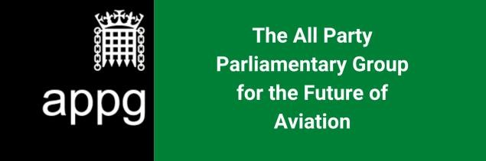

All Party Parliamentary Group for the Future of Aviation: Inquiry into the impacts of Covid-19 on British aviation, travel and tourism sectors and the UK economy

The APPG for the Future of Aviation has today launched its first inquiry since being formally set up on October 6th. This inquiry will investigate the impact of coronavirus on the aviation, travel and tourism sectors and what the consequential impacts are on the UK economy.

Specifically, it will focus on whether adequate support has been provided to these sectors and if not what the consequences will be on local and regional economies and the UK economy more widely.

The inquiry will close on November 23 and the group will look to report by the end of that
month.

The inquiry has set the following questions and will accept any additional information that respondents consider relevant.

Impact of the Coronavirus

- What impact has the virus had on your ability to operate?

- Which Government support measures have you been able to access and how effective have these been in supporting your business?

- Are there schemes that you believe should be able to access but have not been able to?

- What additional measures do you believe the Government should introduce and why?

- Further to recent restrictions placed on international travel in England, are there specific measures that you would like to see introduced to help your business/sector?

- What will impact will the ban on international travel have on your business/sector?

- What impact has COVID-19, and Government restrictions to control the pandemic, had on both outbound travel and inbound visitors to the UK?

- What measures have international Governments taken that you would like to see replicated in the UK?

Recovery

- Without any additional Government support, what do you think your business/sector will look like by the end of 2021?

- What do you believe the impact on the UK economy will be if the Government does not bring forward sector specific support to the aviation, travel and tourism industries?

- With projections showing that air travel may not return to 2019 levels until 2024, what do you believe the impacts will be on a) your local economy or b) the UK economy?

- Do you believe that the Government will be able to meet its Global Britain objectives without a thriving and fully operational aviation industry?

- What measures do you believe should be introduced to support the restart of international travel?

