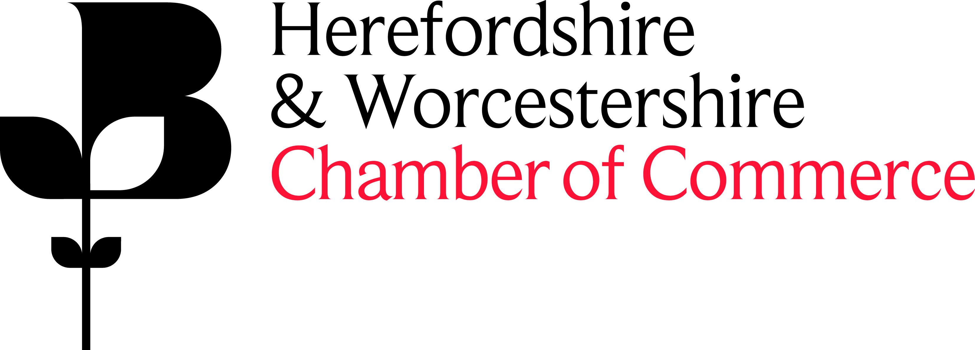

Sponsorship Package – Chamber of Commerce Networking Event or Seminar

Herefordshire Networking Lunch
Thursday 21 August
12.30-2.30pm
The Green Dragon Hotel

Sponsorship of an Event or Seminar costs £500+VAT and in return, your company would receive the following benefits:

- Name of Event or Seminar in association with ‘sponsor company name’ on all publicity. Logo included where possible.
- 2 free attendee places from your business.
- A minimum of 50 free attendees from Chamber member businesses (booked on a ‘first come first served’ basis).
- Opportunity to speak at the event - either as the only speaker or with another speaker (to be agreed with sponsor and subject to confirmation of topic).
- The Chamber will send a follow up email to all attendees to share your contact details to allow attendees to follow up.
- The Chamber will be responsible for promotion of the event.
- The Chamber will be responsible for all communication with the chosen venue.
- The Chamber will provide event materials for the event including name badges and delegates lists.
- The Chamber will process all bookings.
- There will be a link to your website in all emails promoting the event.

We will work with our sponsors to ensure that their objectives are identified at the start of the agreement and delivered throughout the course of the event. A list of the locations and months for breakfasts can be provided upon request (exact dates are to be confirmed).

