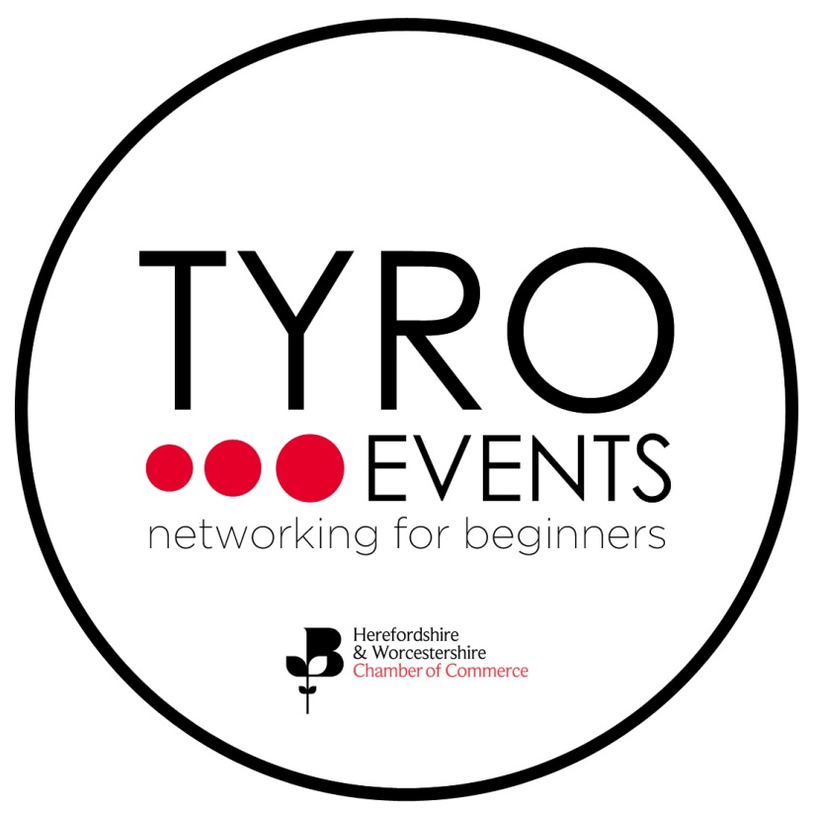

Sponsorship Package-Tyro Events

We have a fantastic new opportunity for local businesses to support the next generation of business professionals through our TYRO Events.

TYRO Events are a series of free events which take place quarterly throughout the year to inspire young professionals to network with other networking beginners and local businesses. Each event will take place at a different venue located in Worcester City Centre with an informative speaker to motivate and develop them in their careers.

Sponsorship of TYRO Events (4 events throughout 2019-2020) will include the following benefits:

- Develop your CSR portfolio by supporting the next generation
- Support the Chamber to help bridge the current skills gap in Worcestershire
- The opportunity to speak for 20 minutes at the event
- A link to your website in all promotional material i.e mailshots, press releases and social media.
- The opportunity to feature in our Business Direction magazine which is distributed to over 1000 businesses.
- Your company name, logo and profile added to the Herefordshire & Worcestershire Chamber of Commerce website on the TYRO pages
- The opportunity to display two pop up banners at the event

The cost of this sponsorship package is £1000+VAT, which will enable the events to be free for attendees.

We will work with our sponsors to ensure that their objectives are identified at the start of the agreement and delivered throughout the course of the event. Dates of our 2019 events are as follows:

Tuesday 25 June 2019
Tuesday 24 September 2019
Tuesday 17 December 2019
Tuesday 31 March 2020

For more information or to register your interest please contact tyroevents@hwchamber.co.uk

