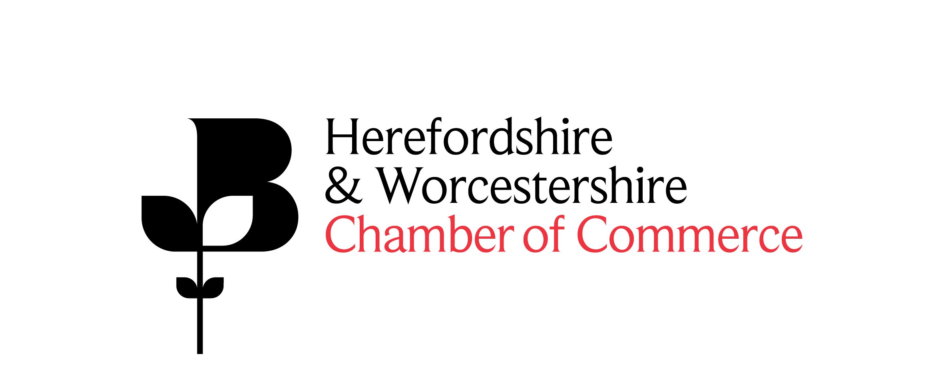

Chamber Business Expo
Thursday 10 October 2019 and Thursday 12 March 2020

Expo Sponsorship Package - Event Sponsor

Sponsorship of the Herefordshire & Worcestershire Business Expo will help to raise the profile of your business, affording your company VIP status at the event and ensuring a prominent position. The sponsorship package for each event will include:

- 1 triple stands (3mx2m) in a central, prominent position
- 1 x pop up banner at the networking breakfast area (250 attendees)
- 5 x breakfast places for staff or guests
- Opportunity to brand the outside entrance area
- Mention as an ‘Event Sponsor’ including company logo in the event programme (1,000 copes)
- Mention as an ‘Event Sponsor’ including company logo on the Chamber of Commerce website
- Mentions on Twitter and Linkedin campaigns for the event
- Mention as a sponsor in all Eshot communications

Total package cost: £3,500.00+VAT

