**[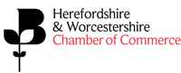](http://hwchamber.co.uk/support/marketing-pr/marketing-online-information)**

**2019 Awards Sponsorship Package   
Networking Drinks Reception**

Association with the 2019 Business Awards will not only enhance your company’s brand further but also give you access to numerous opportunities, worth thousands of pounds, to further raise your profile and demonstrate your commitment to supporting business within Herefordshire and Worcestershire.

**As the Reception Drinks sponsor you will enjoy the following benefits:**

* Four free tickets at the Awards ceremony
* You will receive recognition as a Drinks Reception Sponsor on our Awards website and in all awards publicity
* Display two pop up banners in drinks reception area
* An invitation to join the judging panel for one of the Awards
* Your company name and website will be included in the Awards programme distributed to all 600 guests on the night
* Your company name and logo displayed on the evening of the event via slideshow on event screens
* Your company logo printed on a tag to attach to the necks of all networking drinks glasses

**Our team would be delighted to have a conversation with you to discuss how sponsorship of this prestigious event can meet your business objectives.**

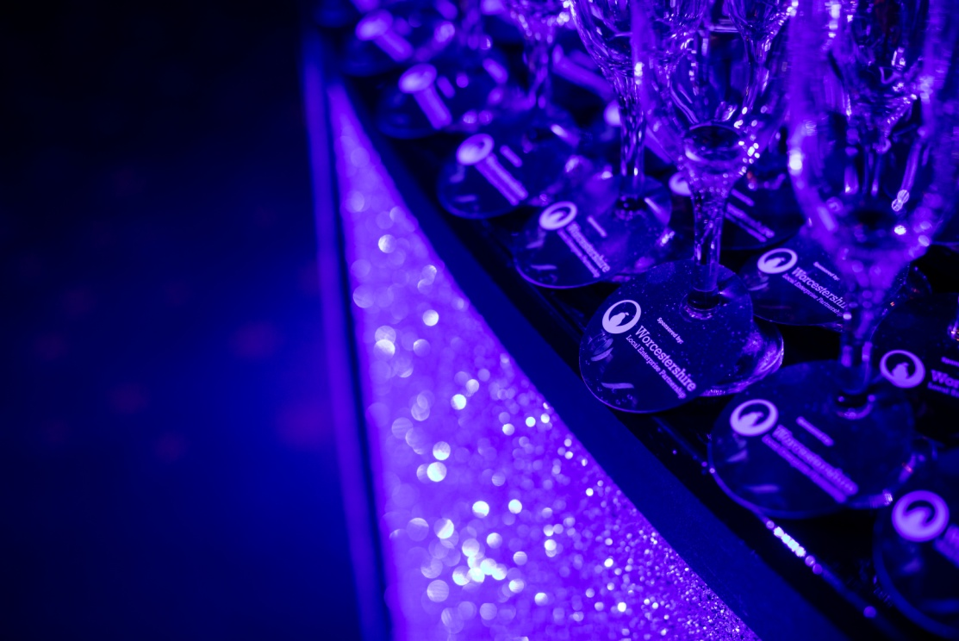

**Cost: £2,000.00+VAT**