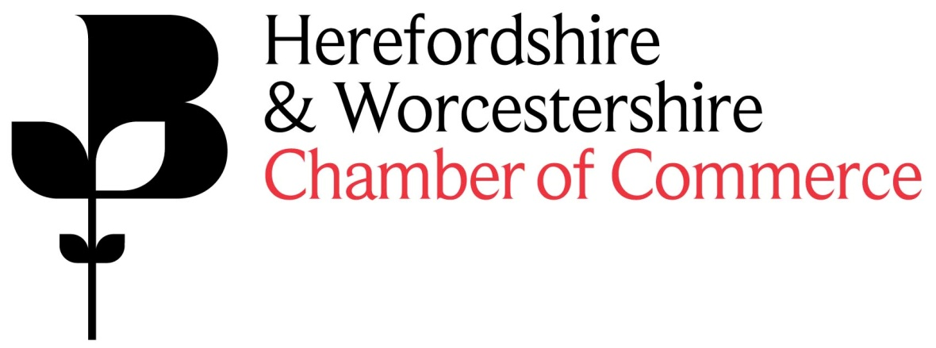
Would you like to join Herefordshire & Worcestershire Chamber of Commerce Area Council?
Herefordshire & Worcestershire Chamber of Commerce has two vacancies on the Worcestershire Area Council.
The Chamber has two Area Councils, one that represents Herefordshire and one that represents Worcestershire.
Area Councils meet six times a year: three meetings per county and three meetings jointly. The Councils are comprised of up to fifteen specialists who represent the majority of sectors in each county.
The Council members provide insights into their sector and discuss the opportunities and challenges businesses currently face. The feedback is then used to formulate Chamber policy on the most important business issues in the region. Any issues that arise at the Area Councils are discussed at a local level and are then referred to the Chamber Board.
Some key responsibilities include:
- Maintaining close contact with members at a local level to help provide guidance to the Board and Chief Executive
- Identifying key issues that needs to be taken up by the Chamber
- Representing both your individual business and your business sector
- Actively supporting the Chamber membership recruitment and retention initiatives
- Acting as an ambassador for the Chamber
We have two vacancies in Worcestershire. We are looking for businesses from the following sectors but would welcome applications from any interested members.
- Food & Drink
- Manufacturing
- Cyber
If you would like to apply for a position, please fill in the self-nomination form which can be downloaded here.
The deadline for receiving applications is 4pm on Monday 25 March 2019.
If you have any questions please contact our Policy department on policy@hwchamber.co.uk

